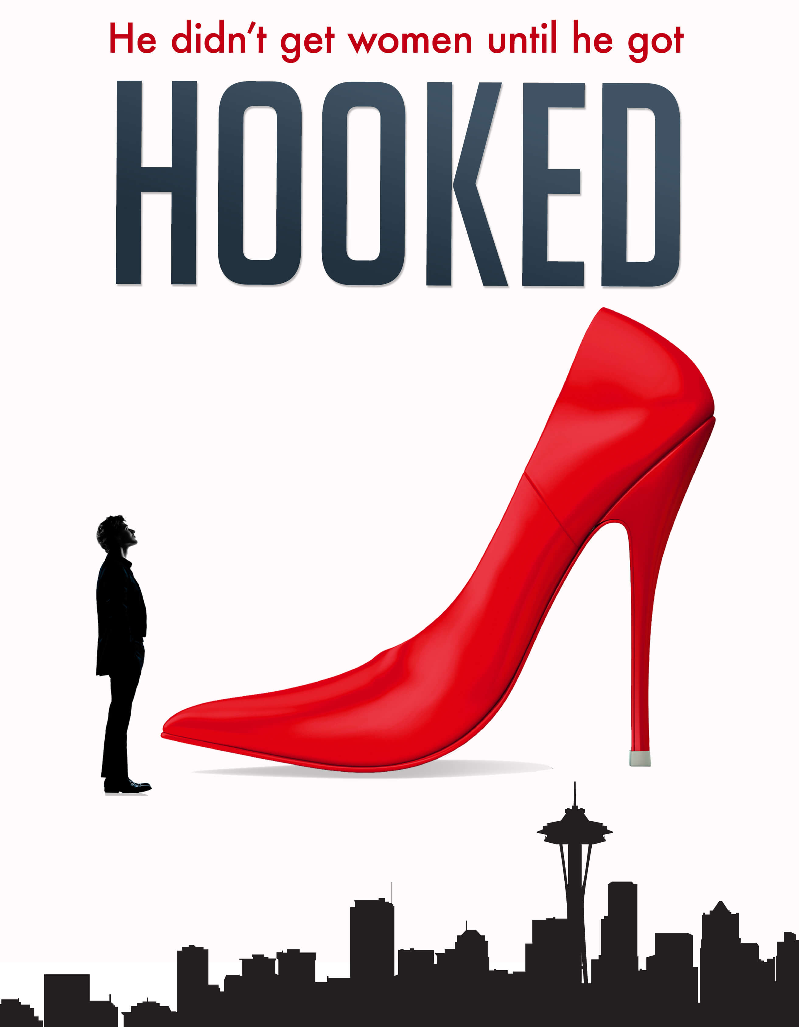

What:
Hooked is a romantic comedy feature-length film about a man who believes he found his perfect soulmate but his autism prevents him from realizing she’s actually a prostitute. The award-winning script for Hooked is based on the acclaimed novel and the story brings crucial awareness to human trafficking as well as autism. For more details, see HookedTheMovie.com.

Who:
Hooked is being produced and created by a team of professionals and over 300 volunteers who are passionate about the story of Hooked, led by filmmaker Allen Wolf. The Hooked film production is sponsored by the 501(c)3 non-profit, From the Heart Productions, so that any contributions, whether cash or non-cash, made toward Hooked are tax-deductible. From the Heart Productions has been dedicated to supporting world-changing films for over 23 years.

When:
Hooked will be shot from August 8-27 in 2018. Postproduction will take place the following fall and winter with the film being complete by spring 2019.

Where:
Hooked will be filmed entirely in Seattle, in the Fremont and University District area and on the Eastside. Post production will also take place in the Seattle area.

How:
Hooked is being produced because of the resources being donated by generous people and organizations. We will highlight these partnerships on HookedTheMovie.com, through our social media, and in the end credits of the film.

Thank you!
Hooked is only possible because of the partnerships and support of hundreds of people and organizations. Thank you for considering supporting our film. We look forward to partnering with you so that Hooked can have a positive impact around the world.

